江西财经大学
16－17学年第二学期期末考试试卷
试卷代码：12104A 授课课时：64(考试时间110分钟)
课程名称：概率论Probability and Statistics 适用对象：2015级国际学院

1. Fill in the blanks (3 points×5=15 points)
(1) Three persons independently decipher a password. The probability they can independently decipher the password is 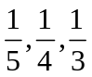, respectively, then the probability that the password deciphered is = 3/5
(2)The pmf of a discrete random variable X is 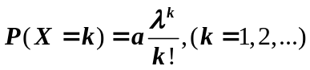, then the parameter is 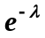
(3) A sample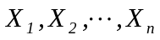is drawn from the population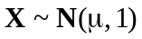,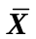is the sample mean, then 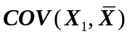= 1/n
(4) If (X,Y) has a cdf 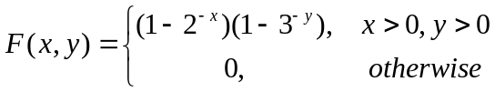 , then 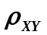(the correlation coefficient)= 0
(5) Suppose 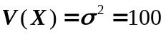, 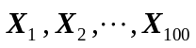is a sample drawn from the population，and the sample mean 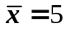, then 90% confidence interval of population mean 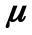 is [3.355 , 6.645]
2. There are four choices in each question, but only one is correct. You should choose the correct one into the blank. (3 points×5=15 points)
(1) If A and B are disjoint events, and 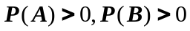, then the correct is ( b )
a. 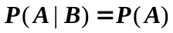 b. 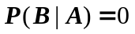
c. 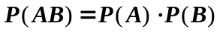 d. 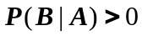

(2) Suppose the pdf (probability density function) of X 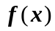is an even function, the cdf (cumulative distribute function) is 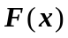, then for arbitrary 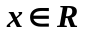, 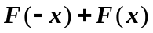= (b )
a.0. b. 1 c.2. d. -1

(3) If 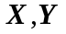are independent random variables, and they each have normal distribution 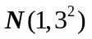, then 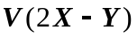=（ c ）
a.-8 b.9 c.45 d.60
(4) A sample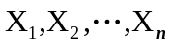is drawn from the population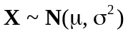, 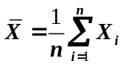is the sample mean, 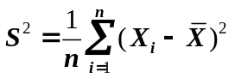is the sample variance, then which of the following is correct ( b )
a.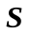is the unbiased estimator of b. 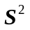is the maximum likelihood estimator of 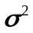
c.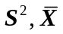are independent d. none of the above

(5) In tests about a normal population mean()，the null hypothesis 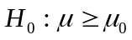, 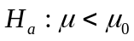. was rejected at significance level =0.02, if selected significance level =0.01，the decision is（ d ）
a. cannot be rejected b. 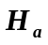 should be rejected
c. should be rejected d. could not conclude a result.

3. (10 points) Forty percent of seeds from maize (modern-day corn) ears carry single spikelets, and the other 60% carry paired spikelets. A seed with single spikelets will procduce an ear with single spikelets 29% of the time, whereas a seed with paired spikelets will produce an ear with single spikelets 26% of the time. Consider randomly selecting ten seeds.
a.What is the probability that exactly five of these seeds carry a single spikelet and produce an ear with a single spikelet?
b.What is the probability that exactly five of the ears produced by these seeds have single spikelets?
Solution: (a) p=0.4*0.29=0.116, P(X=5)=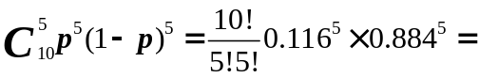0.002857
…………(5points)
(b) p=0.4*0.29+0.6*0.26=0.272, P(X=5)=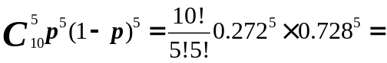0.076719
…………(10points)

4. (12 points) Let X₁,X₂,..,X_{n} be random variables denoting n independent bids for an item that is for sale. Suppose each X_{i} is uniformly distributed on the interval [100,200]. If the seller sells to the highest bidder, how much can he expect to earn on the sale?
Solution: the pdf of X_{i} is 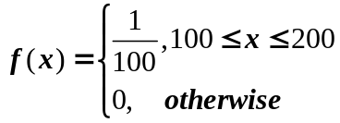, set Y=max(X₁,X₂,..,X_{n}) ……(2points)
The cdf of Y 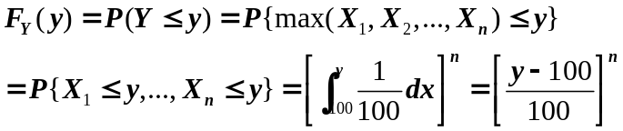 …………(6points)
The pdf of Y 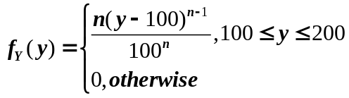…………(8points)
he expect to earn on the sale
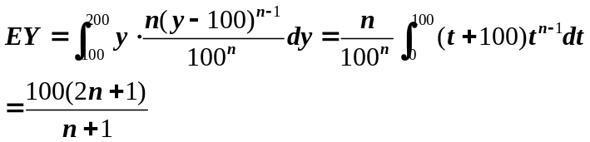…………(12points)

5. (12 points) Suppose X and Y are independent random variables with pdf’s
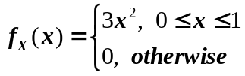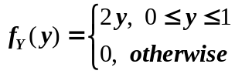
Determine the pdf of Z=X+Y
Solution: the cdf of Z 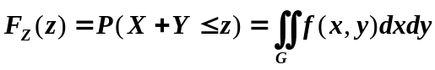
(1)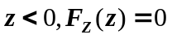 …………(2points)
(2)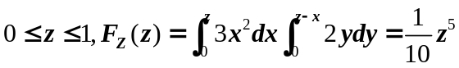 …………(5points)

(3) 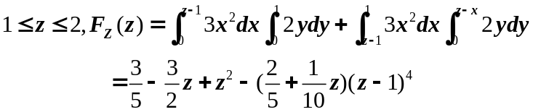…………(8points)
(4)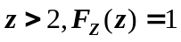 …………(10points)

So, the pdf of Z is 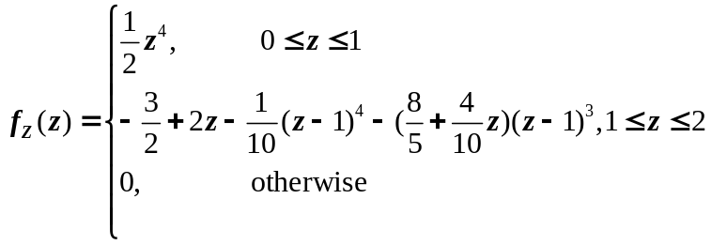…………(12points)
6. (12 points) Let μ denote the true PH of chemical compound. A sequence of n independent sample PH determinations will be made. Suppose each sample PH is a random variable with expected value μand standard deviation 0.1. How many determinations are required if we wish the probability that the sample average is within 0.02 of the true PH to be at least 0.95?
Solution: 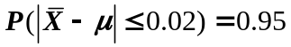, 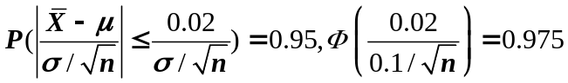
…………(10points)
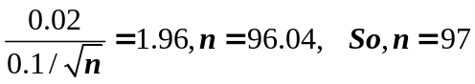
…………(12points)

7. (12 points) The financial manager of a large department-store chain selected a random sample of 200 of its credit card customers and found that 136 had incurred an interest charge during the previous year because of an unpaid balance.
a. Compute a 90% CI for the true proportion of credit card customers who incurred an interest charge during the previous year.
b. If the desired width of the 90% interval is 0.05, what sample size is necessary to ensure this?.
Solution: (a) a 90% CI for the true proportion is 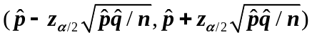,…(4points)
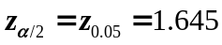, the CI is 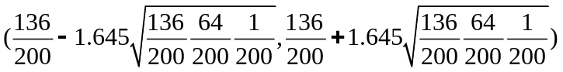
That is CI= (0.62574, 0.73426) …………(6points)
(b) the desired width of the 90% interval is 0.05, 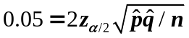,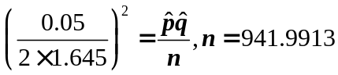. So n=942 …………(12points)

8. (12 points) The desired percentage of Sio₂ in a certain type of aluminous cement is 5.6. To test whether the true average percentage is 5.6 for a particular production facility, 25 independently obtained samples are analyzed. Suppose that the percentage of SiO₂ in a sample is normally distributed with σ=0.3 and that 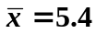
- State the appropriate null and alternative hypotheses, and test the hypotheses with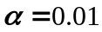.
- If the true average percentage is μ=5.4 and a level test based on n=25 is used, what is the probability of detecting this departure from H₀?
Solution: (a) the null and alternative hypotheses 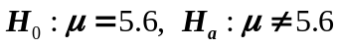………(2points)
Test statistic is 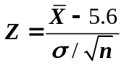
The reject region is ……(4points)
The sample data is 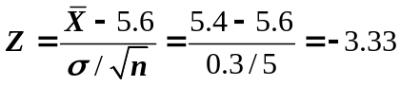<-2.58, so reject null hypothesis H₀
………62points)
(b)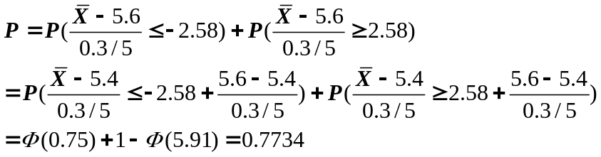
………(12points)

Table:
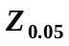 | 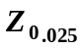 | 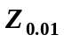 | 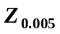
1.645 | 1.96 | 2.33 | 2.58

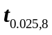 | 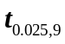 | 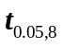 | 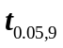
2.306 | 2.262 | 1.860 | 1.833

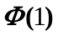 | 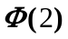 | 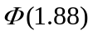 | 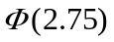 | 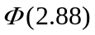 | 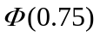
0.8413 | 0.9772 | 0.9699 | 0.9970 | 0.9980 | 0.7734

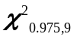 | 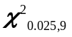 | 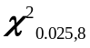 | 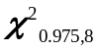 | 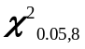 | 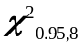 | 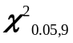 | 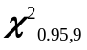
2.700 | 19.022 | 17.534 | 2.180 | 15.507 | 2.733 | 16.919 | 3.325

